GAME OF 21
UI DESIGN DOC

Student Name #1: Hussaina Hussain Student Name #2: Han Lee
Student Number #1: 3136381 Student Number #2: 3162019

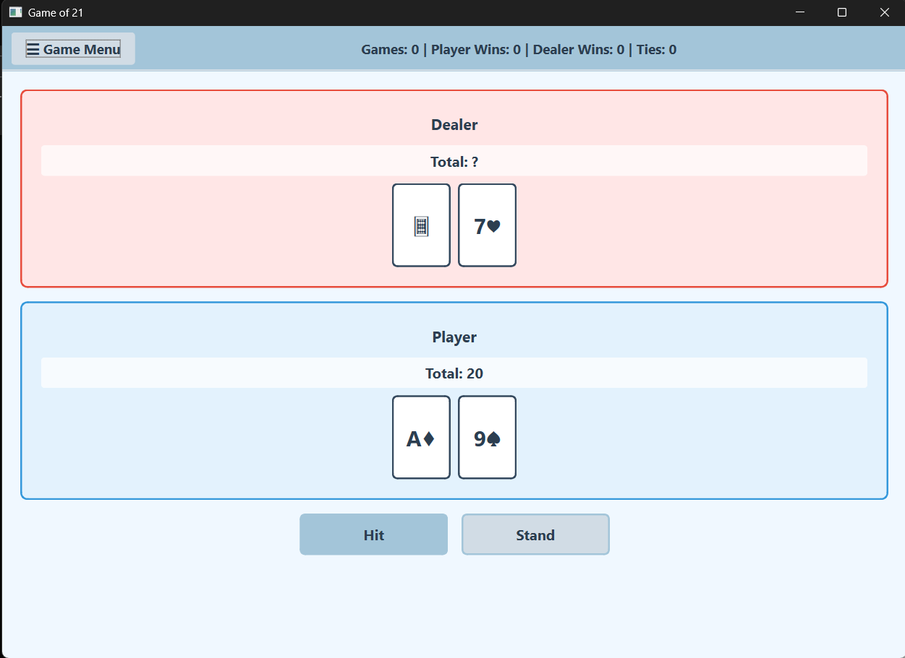

The application uses a QMainWindow structure divided into three primary regions:
- Top Ribbon (Status Bar)
- Sliding Sidebar (Game Menu)
- Central Game Area

This structure ensures that global information and controls are consistently visible, while
gameplay remains the primary focus.

COMPONENTS
- Top Ribbon – Game Statistics
Location: Fixed at the top of the window, so that the players can view the stats easily and don’t have to look for them.
Widgets Used: QFrame, QLabel, QPushButton
Displayed Information: Total games played, Player wins, Dealer wins, Ties (Push).
Design Rationale:
- Placing statistics at the top aligns with the principle of Visibility of System Status (Nielsen). The user can immediately see the current state of the game without performing any action.
- A horizontal ribbon layout follows common gaming and application conventions, improving familiarity.
- The statistics label is centered to balance the left-aligned menu button, creating visual symmetry (Gestalt: Balance and Alignment).

- Sliding Slidebar – Game Menu
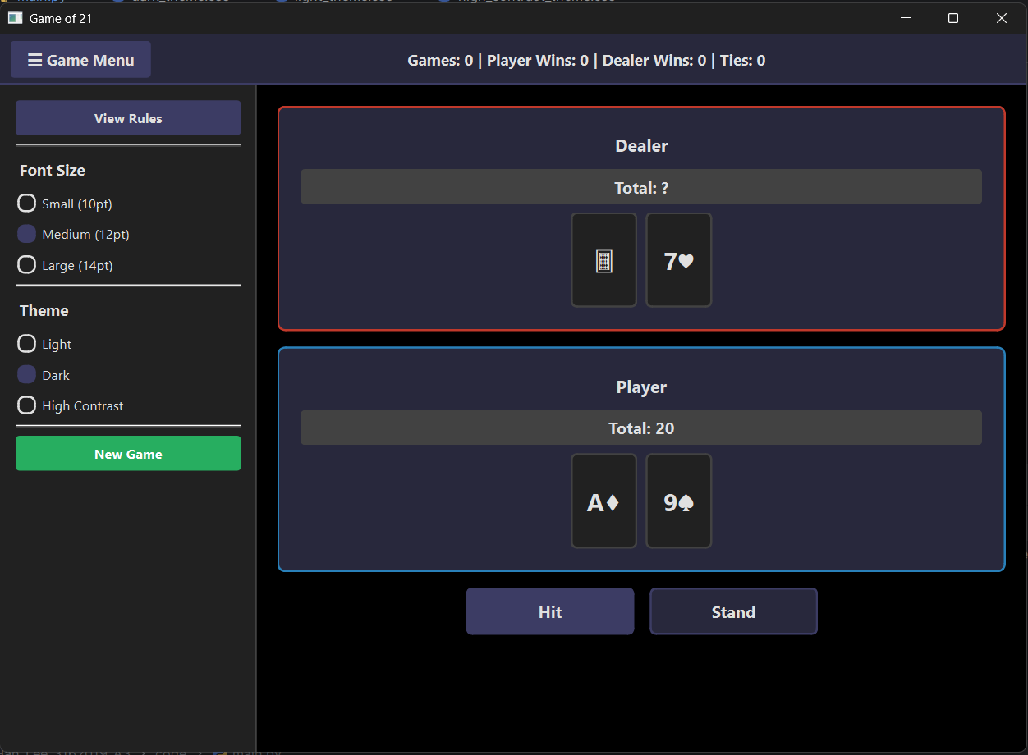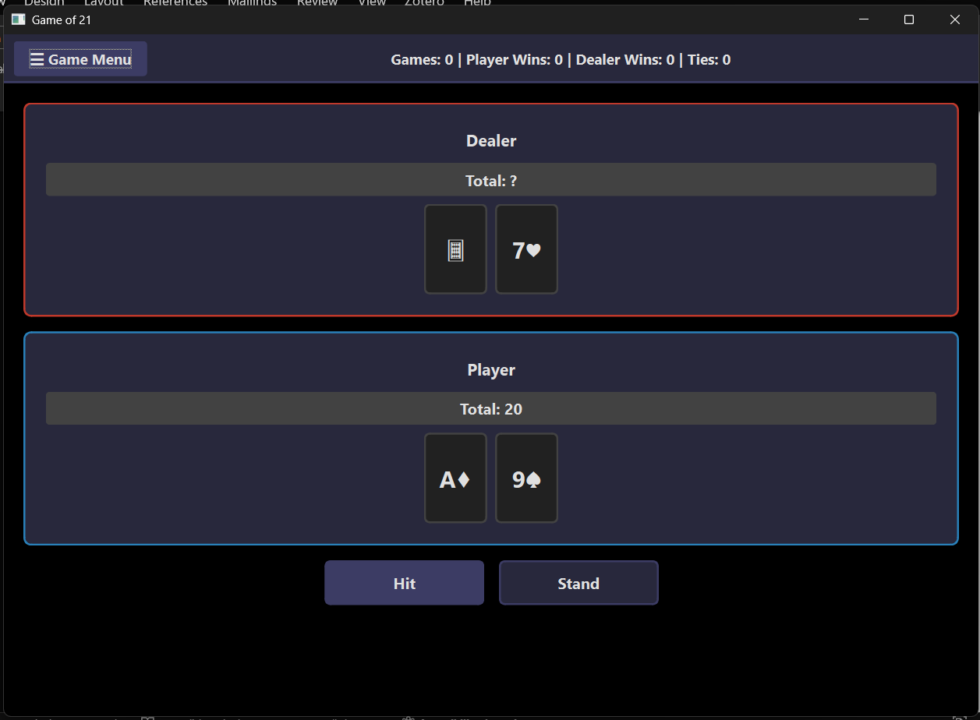
The sidebar contains secondary controls that should be accessible but not visually dominant during gameplay.
Location: Left side of the window
Widget Used: QFrame with QVBoxLayout
Sidebar Contents: View Rules button, Font size selection (Small, Medium, Large), Theme selection (Light, Dark, High Contrast), New Game button
Design Rationale:
- The sidebar is hidden by default and toggled using the “Game Menu” button. This reduces visual clutter and supports Aesthetic and Minimalist Design.
- Left placement follows standard UI conventions and matches left-to-right reading patterns.
- Controls are grouped vertically using proximity (Gestalt: Proximity) to clearly indicate related functionality.

- Rules Dialog
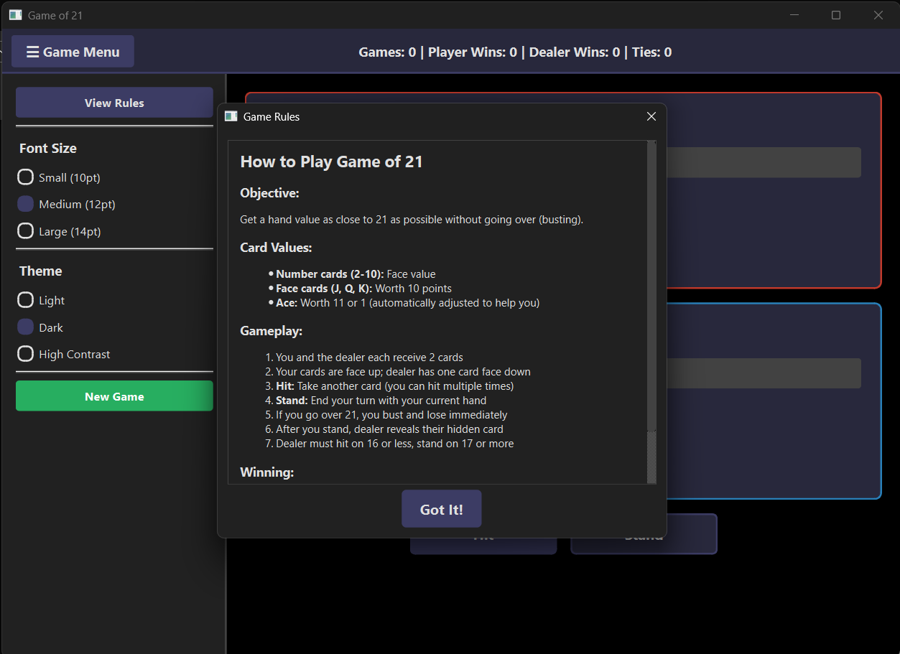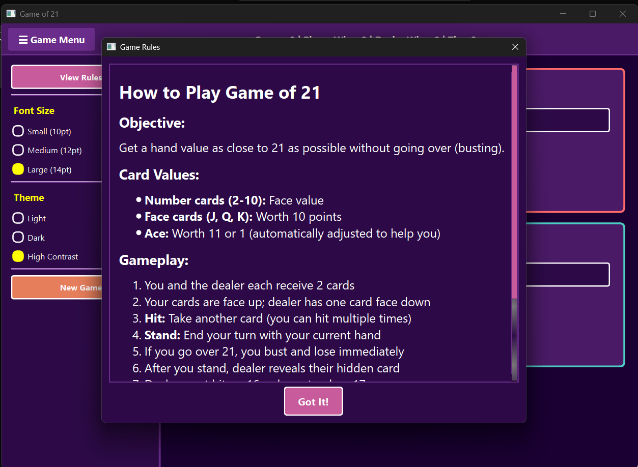
Location: Within the Sidebar.
Widget Used: QDialog with QScrollArea
Design Rationale:
- Modal dialog ensures the user focuses on the rules when opened.
- Scrollable content prevents excessive window size while maintaining readability.
- Supports Recognition Rather Than Recall by allowing users to revisit rules at any time.

- Font Size Controls
The font size controls only apply to the Game Rules display, everything else in the game (centre display) is of standard size and will get adjusted according to the screen size.
Location: Within the Sidebar.
Widget Used: QRadioButton
Justification:
- Radio buttons clearly indicate mutually exclusive choices.
- This supports accessibility by allowing users to adjust text size based on personal preference or visual needs.

- Theme Selection
Location: Within the Sidebar.
Available Themes: Light, Dark, High Contrast
Implementation: External Qt stylesheet files loaded dynamically.
Design Rationale:
- Theme switching improves accessibility and personalization.
- High Contrast mode was specifically included to support users with visual impairments.
- Using external stylesheets ensures visual consistency and easier maintenance.

- Central Game Area

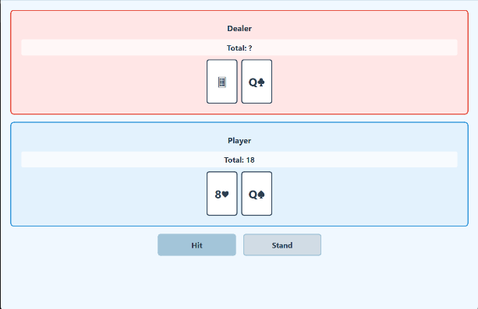

The central area is the primary focus of the application and contains all gameplay-related information.
It contains of the Dealer and Player Section.

- Dealer Section
Widgets Used: QFrame, QLabel, QHBoxLayout
Displayed Elements: Dealer label, Dealer total (hidden until reveal), Dealer cards (one face-down initially)
Design Rationale:
- The dealer section is placed at the top to reflect real-world card table conventions (Match Between System and Real World).
- The hidden card reinforces suspense and mirrors real Blackjack gameplay.
- Red border accents visually distinguish the dealer area from the player area.

- Player Section
Widgets Used: QFrame, QLabel, QHBoxLayout
Displayed Elements: Player label, Player total, Player cards
Design Rationale:
- Positioned below the dealer section to establish a clear vertical flow of information.
- Blue border accents contrast with the dealer’s red section, helping users differentiate roles at a glance (Gestalt: Similarity and Contrast).

- Action Controls

Buttons: Hit, Stand
Design Rationale:
- Buttons are centered horizontally and placed below the player’s cards, matching the natural interaction flow.
- Disabled automatically at the end of a round to prevent invalid actions, supporting Error Prevention.
- Button size and spacing were chosen to reduce accidental clicks and improve usability.

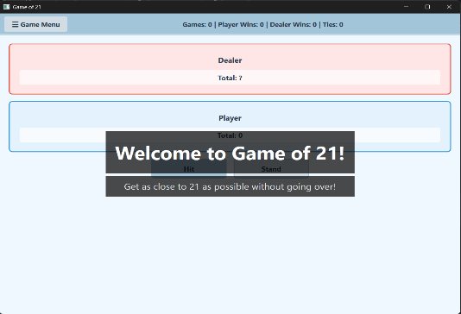
- Welcome Overlay

Location: Centre of the screen, to grab immediate attention.
Purpose: Introduce the game and set expectations before play begins.
Design Rationale:
- Semi-transparent overlay draws attention without overwhelming the interface.
- Automatically dismissed after a short delay, minimizing required user interaction.

- Result Dialogue Box
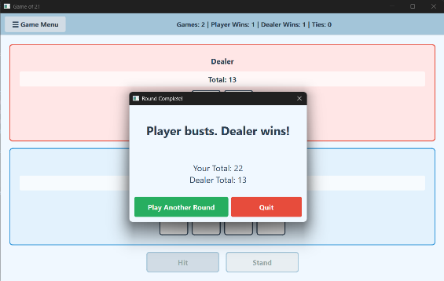
Location: Centre of the screen, to grab immediate attention.
Purpose: Provide clear feedback at the end of each round.
Displayed Information:
- Win / lose / push message
- Player and dealer totals
- Options to play another round or quit
Design Rationale:
- Modal dialog enforces acknowledgment of the outcome.
- Clear action choices support User Control and Freedom.

- Accessibility Considerations
The application was designed with accessibility as a core requirement:
- Adjustable font sizes
- High contrast theme option
- Clear foreground/background contrast in all themes
- Large, clearly labelled buttons
- No reliance on colour alone to convey information

- Usability Heuristics and Gestalt Principles
Nielsen’s 10 Usability Heuristics (Applied Examples)
- Visibility of System Status: Live statistics and hand totals
- Match Between System and Real World: Blackjack terminology and flow
- User Control and Freedom: Quit and New Game options
- Consistency and Standards: Uniform button styles and layouts
- Error Prevention: Disabled controls at end of round
- Recognition Rather Than Recall: Rules dialog and visible totals
- Aesthetic and Minimalist Design: Clean layout with hidden sidebar

Gestalt Principles
- Proximity: Grouping of related controls in the sidebar
- Similarity: Consistent card and button styling
- Contrast: Differentiation between dealer and player sections
- Alignment: Centered layouts for visual balance

ADDITIONAL FEATURES
- Theme Switching
- Restart Game Confirmation Box
- Font Sizing Options
- Statistics Tracker
- Multiple Rounds (The thing with this feature is that you can keep playing as many rounds as you want, and the stats will keep getting updated.)

COLLABORATION
We used github to collaborate for this assignment. Both the code and creation of the UI design doc was divided 50-50 between the two of us.
Link to the demo video:
REFERENCES
- Avery, N. (2012). 21 Card Game. [online] Planning With Kids. Available at: https://planningwithkids.com/2012/06/20/21-card-game/.
(Website we used to get a better understanding of the game, has the rules in more precision is all.)
- Riverbank Computing, 2025. PyQt6 Reference Guide. [online] Available at: https://www.riverbankcomputing.com/static/Docs/PyQt6/ [Accessed 12 December 2025].
- Qt Company, 2025. QGraphicsEffect Class Reference. [online] Available at: https://doc.qt.io/qt-6/qgraphicseffect.html [Accessed 13 December 2025].
(Used this site to help with the card display)
- PyCharm Help. (2025). PyCharm Help. [online] Available at: https://www.jetbrains.com/help/pycharm/working-with-git-tutorial.html#create-test-prj [Accessed 18 Dec. 2025].
- PyCharm Help. (2025). PyCharm Help. [online] Available at: https://www.jetbrains.com/help/pycharm/version-control-integration.html [Accessed 18 Dec. 2025].
(Used this site to connect pycharm to github, we used github to collaborate on this assignment.)
- Stack Overflow. (n.d.). PyQt6 Application Crashes When Window is Moved or Resized During Video Capture with opencv. [online] Available at: https://stackoverflow.com/questions/78352175/pyqt6-application-crashes-when-window-is-moved-or-resized-during-video-capture-w [Accessed 18 Dec. 2025].
(Our application was crashing upon resizing, this article helped us out a lot.)
- Geeksforgeeks.org. (2025). Welcome To Zscaler Directory Authentication. [online] Available at: https://www.geeksforgeeks.org/css/difference-between-inline-internal-and-external-css/ [Accessed 18 Dec. 2025].
(This site helped us when a quick fix for our display styling messed our code, we had added inline styling to modify the colour of the text on our result display box. That didn’t go very well, not attaching that site since we didn’t go ahead with that approach after all. But this article helped us realize our mistake and fix it too.)
- ‌ CodeQuestions (2023). PyQt6 Programs | Animated Sidebar Menu Example. [online] YouTube. Available at: https://www.youtube.com/watch?v=KxHFFHqeqG0 [Accessed 18 Dec. 2025].
(Sliding Sidebar tutorial for extra help we needed apart from the lab content)
- monotype (2022). Dynamic theme changing in PyQt application. [online] Stack Overflow. Available at: https://stackoverflow.com/questions/73914135/dynamic-theme-changing-in-pyqt-application.
(how to apply different colour themes)

Application demo link: https://youtu.be/u29XIYqPiU0

